Activity Exemplar: Create an Exploration in Google Analytics
Here is a completed exemplar along with an explanation of how the exemplar fulfills the expectations for the activity.
Completed Exemplar
To review the exemplar for this course item, click the link below and select “Use Template.”
Link to exemplar: Record of events, metrics, and insights
Assessment of Exemplar
Compare the exemplar to your completed document. Review your work using each of the sections in the exemplar. What did you do well? Where can you improve? Use your answers to these questions to guide you as you continue to progress through the course.
Note: The exemplar was created using metrics from the Google Merchandise Store collected between October 15, 2021 and December 15, 2021 for the following events:
- December 8-9, 2021 - Cloud Learn - Global
- December 2, 2021 - GFSA Women Founders: Demo Day 2021 - Global
- December 2, 2021 - Gaming Day on Google Open Source Live - Global
The data was used to complete the exemplar and explore if the following trend exists: Do active users and purchases in the Google Merchandise Store go up when a developer event occurs, including the day immediately prior to and the day immediately after an event?
Developer events
For your own analysis, you selected the most recent three developer events listed for the current year and added them to your activity template.
Free-form exploration of active users
For the events chosen in the exemplar, the free-form exploration of active users resulted in the following line chart.
Note: Because events and dates differ, your line chart will vary.
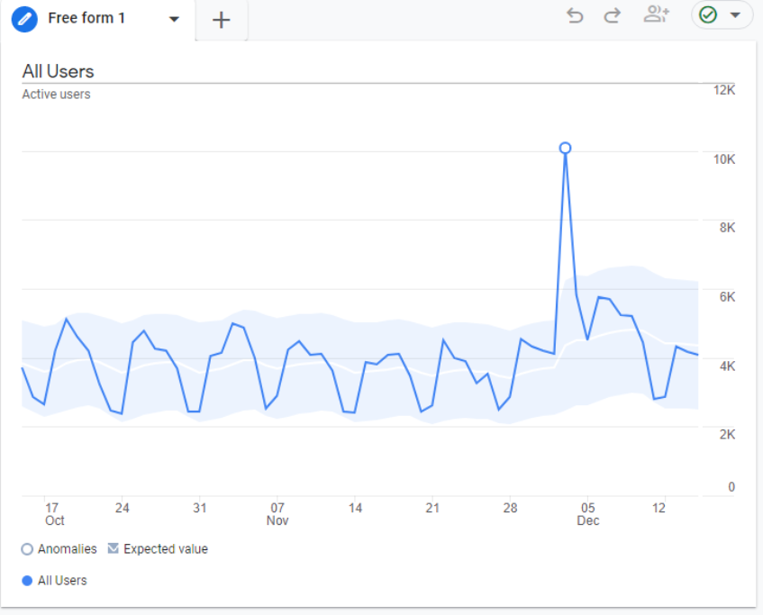Line chart shows active user counts on dates between October 15 and December 15, 2021. There was a spike up to 10,000 users on December 3 when all other dates had fewer than 6,000 users.
This visualization showed a significant positive anomaly (spike) on December 3, 2021 which could possibly be related to the two developer events held on December 2, 2021:
- December 2, 2021 - GFSA Women Founders: Demo Day 2021
- December 2, 2021 - Gaming Day on Google Open Source Live
In the exemplar, the Anomalies column of the table in the activity template was marked for these two events. Hovering over the spiking data point revealed additional details as shown below. This information was also added to the Observations section of the activity template.
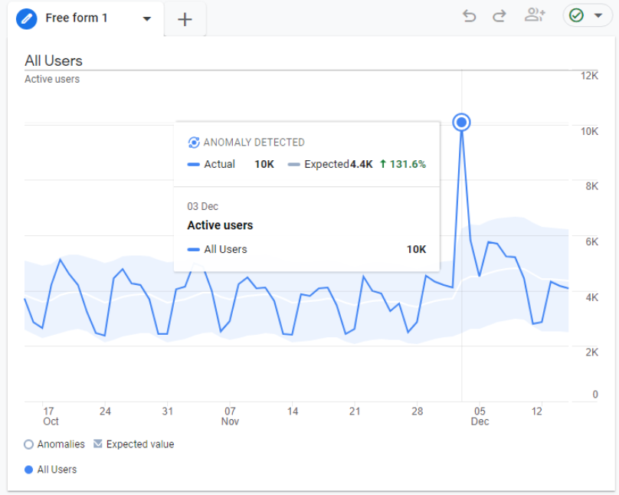The data point reveals 10,000 actual users and 4,400 expected users, at an increase of 131.6 percent.
Free-form exploration of purchases
For the events chosen in the exemplar, the free-form exploration of purchases resulted in the following line chart with no anomalies detected during or within a day of the two developer events on December 2, 2021.
Note: Because events and dates differ, your line chart and detected anomalies will vary.
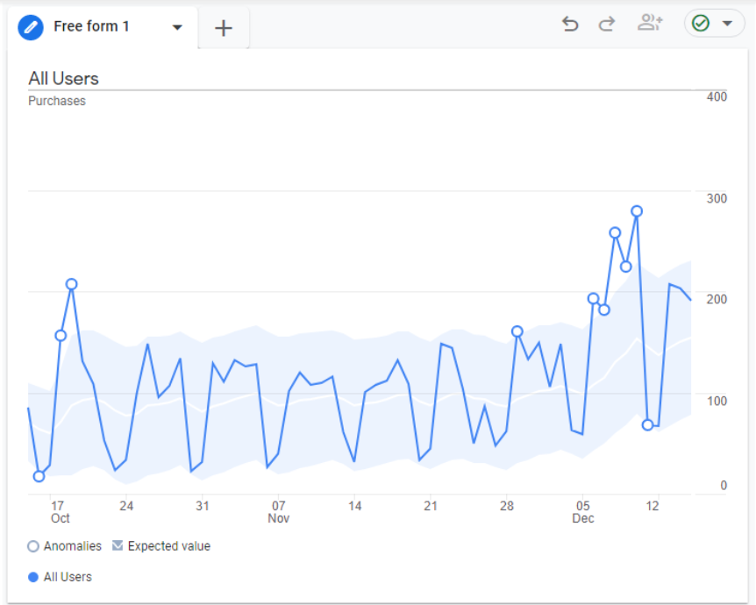
Purchase anomalies were detected on November 29 and December 6, but these anomalies are most likely unrelated to the events. With a 2-4 day separation, there is lack of proximity to the events. For instance, the anomaly that occurred on December 6 was probably unrelated to the Cloud Learn event that started two days later on December 8, 2021. These observations were added to the Observations section of the activity template.
Insights
Based on the analysis from the exploration, the conclusion was there was no relationship between active users and purchases in the Google Merchandise Store and developer events held in December 2021. No further action was recommended to continue monitoring these metrics during developer events.

